Question 1:
/**
* The simple program
* Author: Adrian Pailler
* Date: 22/1/21
* Version: 1.0
* Description: uses GUI to display user input. Focus on use of methods.
*/
package Methods;
import javax.swing.*;
public class Q1 {

public static void main(String[] args) {
String Title = Title(); // see 17-25
String something = JOptionPane.showInputDialog(null, "Enter something: ",Title,0); // asks for user input
JOptionPane.showMessageDialog(null, "You entered: "+something,Title, 0); // displays the same user input "something"
}
/**
* Creates the title for the GUI input dialog
* no parameters
* returns the title
*/
private static String Title() {
final String Title = "The simple program";
return Title;
}

}
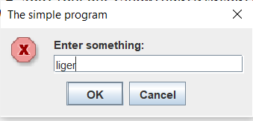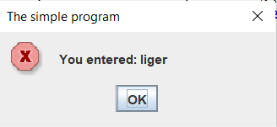

Question 2:
/**
* power calculator
* Author: Adrian Pailler
* Date: 22/1/21
* Version: 1.0
* Description: calculates the power of a base to an exponent even with negative powers
*/
package Methods;

import javax.swing.*;

public class Q2 {
static final String title = "Powers and Exponents"; // since title is reused, creating it as a string is more efficient
public static void main(String[] args) {
int flag = 0; // flag to efficiently break out
while(flag==0) {
JOptionPane.showMessageDialog(null, "Welcome to Powers and Exponents",title,0);
double ans = power(Double.parseDouble(JOptionPane.showInputDialog(null, "Enter a base: ",title,0)),Integer.parseInt(JOptionPane.showInputDialog(null,"Enter an exponent: ",title,0)));
// call power (see 27-40) and gets values for base and exponent (in order)
JOptionPane.showMessageDialog(null, "The answer is: "+ans); // displays the answer
flag =JOptionPane.showConfirmDialog(null, "whould you like to play again?",title,0); // uses flag to decide to repeat program and stay in loop or not
}
if(flag==1) {
JOptionPane.showMessageDialog(null, "Thank you for playing powers and exponents!",title,0); // uses flag to initiate code at end
}
}
/**
* calculates the power
* two double/integer values (base and exponent) parameters which are set on line 32
* is recursive therefore returns and calls itself
*/
public static double power(double base, int exponent) {
if(exponent > 0){ // finds whether exponent is +ve
return base*power(base, exponent-1); // multiplies base by itself until exponent is 1
}else if(exponent < 0){ // finds whether exponent is -ve
return 1/power(base, -exponent); // changes the sign of the exponent and puts it under 1/. after return it goes through 33-34
}else{ // exponent is 0
return 1;
}
}
}
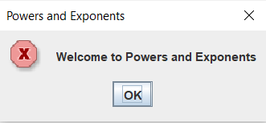
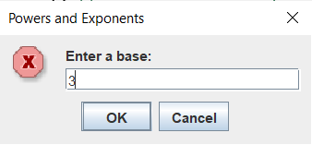
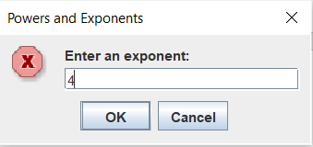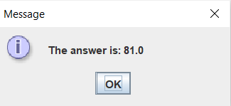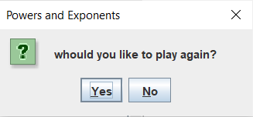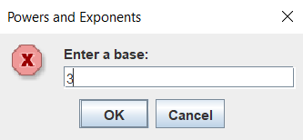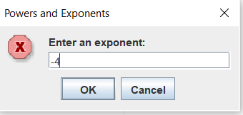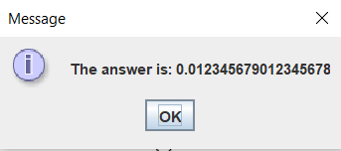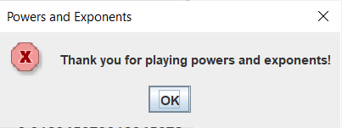

Question 3:
/**
* Volume calculator
* Author: Adrian Pailler
* Date: 23/1/21
* Version: 1.0
* Description: Uses user input to calculate the volume of a cylinder
*/
package Methods;
import javax.swing.*;
public class Q3 {
static final String title = "Volume Calculator"; // since title is reused, creating it as a string is more efficient
public static void main(String[] args) {
int flag = 0;// flag to efficiently break out
while(flag==0) {
JOptionPane.showMessageDialog(null,"Welcome to Volume Calculator",title,0);
double ans = input(); // calls input and receives the answer ()
JOptionPane.showMessageDialog(null, "The volume is: "+ans);// displays the answer
flag =JOptionPane.showConfirmDialog(null, "whould you like to play again?",title,0); // uses flag to decide to repeat program and stay in loop or not
}if(flag==1) {
JOptionPane.showMessageDialog(null, "Thank you for using volume calculator",title,0); // uses flag to initiate code once user does not wish to continue
}
}
/**
* gets the users inputs
* no parameters
* returns double answer
* calls calculator method (42-50)
*/
public static double input() {
JTextField one = new JTextField();
JTextField two = new JTextField();
Object [] constants = {
"radius: ",one,
"height: ",two,
}; // creates two input dialogs
JOptionPane.showConfirmDialog(null,constants,"Input the radius and the height: ", 0);
double radius = Double.parseDouble(one.getText());// gets and converts values in the same line
double height = Double.parseDouble(two.getText());
double ans = calculator(radius,height); // could be more clearer and direct but just for the sake of using methods
return ans; // returns to main
}
/**
* calculates the volume
* two doubles (radius and height)
* returns the answer from the calculation
*/
public static double calculator(double r, double h) {
double ans = r*r*h*Math.PI; // calculates the volume
return ans; // returns to input()
}

}
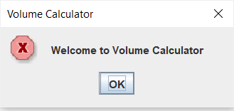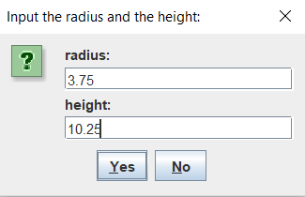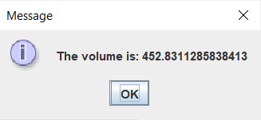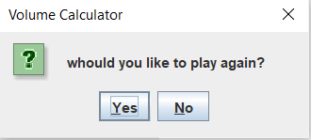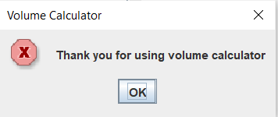

Question 4:
/**
* Format with commas
* Author: Adrian Pailler
* Date: 23/1/21
* Version: 1.0
* Description: Takes an Integer as a parameter (up to 10 digits)
* and returns a string which is the number with properly places commas
*/
package Methods;

import javax.swing.JOptionPane;
public class Q4 {
static StringBuffer str = new StringBuffer();
static final String title = "Formatting Numbers"; // since title is reused, creating it as a string is more efficient
public static void main(String[] args) {
int flag = 0;// flag to efficiently break out
while(flag==0) {
JOptionPane.showMessageDialog(null,"Welcome to Formatting with Numbers",title,0);
StringBuffer ans = formatwithcommas(str.append(JOptionPane.showInputDialog(null,"Enter an Integer: "))); // calls method(27-44) and gets user input integer
JOptionPane.showMessageDialog(null, "The formatted number is: "+ans);// displays the answer
flag =JOptionPane.showConfirmDialog(null, "whould you like to play again?",title,0); // uses flag to decide to repeat program and stay in loop or not
str.delete(0, str.length());
}if(flag==1) {
JOptionPane.showMessageDialog(null, "Thank you for using number formatter",title,0); // uses flag to initiate code once user does not wish to continue
}
}
/**
* formats the integer with commas. Does this from the end to index 0
* uses stringBuffer
* returns the stringBuffer answer
*/
public static StringBuffer formatwithcommas(StringBuffer num) {
int i = num.length();
while(i!=0){
if (i-3>0) { // makes sure the index is not below 0
num.insert(i-3, ","); // inserts a comma every 3 indexes
i=i-3;
}else { // breaks out of loop
i=0;
}
}
return num;

}

}

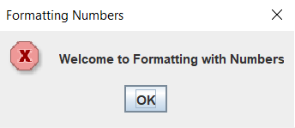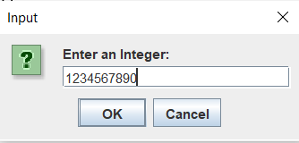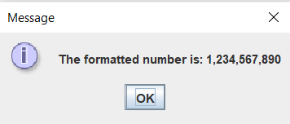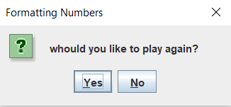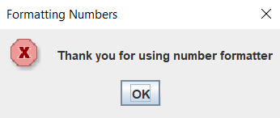

Question 6:
/**
* Fraction Reducer
* Author: Adrian Pailler
* Date: 25/1/21
* Version: 1.0
* Description: fraction is reduced to numerator and denominator
*/
package Methods;

import javax.swing.*;
public class Q6 {

public static void main(String[] args) {
final String title = "Fraction reducer"; // since title is reused, creating it as a string is more efficient
int flag = 0; // flag to break efficiently
while(flag==0) {
JOptionPane.showMessageDialog(null,"Welcome to Fraction reducer",title,0);
String input = JOptionPane.showInputDialog(null,"Enter the fraction: ",title,0);
if(input.contains("/")) { // makes sure input is a fraction
int denominator = getDenominator(input); // calls getdenominator(77-87)
int numerator = getNumerator(input); // calls getnumerator(65-75)
String reduction = reduce(numerator,denominator); // calls reduction (33-63)
JOptionPane.showMessageDialog(null, "The numerator is: "+numerator+"\n The denominator is: "+denominator+"\n The reduced fraction is: "+reduction,title,0);
} else { // if it is not a fraction
JOptionPane.showMessageDialog(null, "That is not fraction! Your interllect is questionable...",title,0);
}
flag = JOptionPane.showConfirmDialog(null, "would you like to try again?",title,0); // loops back to 16 player chooses yes
}
if(flag==1) {
JOptionPane.showMessageDialog(null,"Bye!",title,0);
}
}
/**
* reduces the fraction to its smallest form
* takes in two int values (numerator and denominator of fraction)
* returns the answer of the reduction
*/
public static String reduce(int numerator, int denominator) {
int largest;
int n = numerator, d = denominator;
String ans;
if (numerator < 0) {
n = -numerator;
}
if (n > d) { // checks if it is a improper fraction
largest = n;
} else {
largest = d;
}
int gcd = 0;
for (int i = largest; i >= 2; i--) {
if (numerator % i == 0 && denominator % i == 0) {
gcd = i; // gets the greatest common factor
i=0;
}
}
if (gcd != 0) { // divides both by the greatest common factor to reduce them
numerator /= gcd;
denominator /= gcd;
}
ans= numerator+"/"+denominator; // puts both back together
return ans;
}
/**
* gets the numerator from the fraction string
* takes a String for the fraction
* returns the numerator
*/
public static int getNumerator(String fraction) {
int numerator;
int index = fraction.indexOf("/");
numerator = Integer.parseInt(fraction.substring(0,index)); // gets the value before the '/'
return numerator;
}
/**
* gets the denominator from the fraction string
* takes a String for the fraction
* returns the denominator
*/
public static int getDenominator(String fraction) {
int denominator;
int index = fraction.indexOf("/")+1;
denominator = Integer.parseInt(fraction.substring(index,fraction.length()));// gets the value after the '/'
return denominator;
}
}
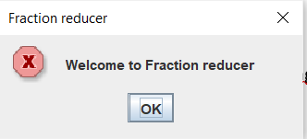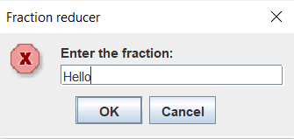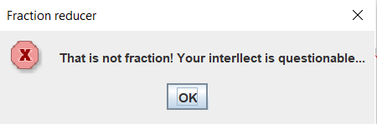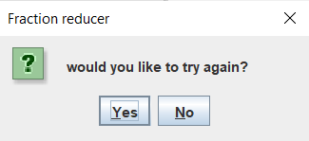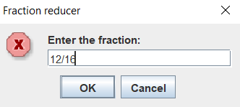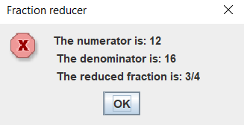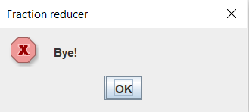

Question 7:

/**
* Drivers education
* Author: Adrian Pailler
* Date: 25/1/21
* Version: 1.0
* Description: converts time into a standard time format
*/
package Methods;

import javax.swing.*;

public class Q7 {

public static void main(String[] args) {
final String title = "Driver's education department"; // since title is reused, creating it as a string is more efficient
int flag = 0; // flag to break efficiently
while(flag==0) {
JOptionPane.showMessageDialog(null,"Welcome to driver's education",title,0);
int[] arr =readTime();
displayTime(arr[0],arr[1]);
flag = JOptionPane.showConfirmDialog(null, "would you like to try again?",title,0); // loops back to 16 player chooses yes
}
if(flag==1) {
JOptionPane.showMessageDialog(null,"Bye!",title,0);
}
}
/**
* gets the users input minutes and seconds
* no parameters
* no returns
*/
public static int[] readTime() {
SpinnerModel limits = new SpinnerNumberModel(1,0,10000000,1);
SpinnerModel limit = new SpinnerNumberModel(1,0,10000000,1);// initial, min, max, step
JSpinner minutes = new JSpinner(limits); // creates spinner
JSpinner seconds = new JSpinner(limit);
Object [] spinners = {
"Enter minutes: ",minutes,
"Enter seconds: ",seconds,
};
JOptionPane.showConfirmDialog(null,spinners);
int min = (int) minutes.getValue();// gets and converts values in the same line
int sec = (int) seconds.getValue();
int[] arr = new int[2];
arr[0]=min; arr[1]=sec; // can only return one object
return arr;
}
/**
* puts the time in the correct format
* int int for the minutes and seconds
* returns the answer
*/
public static void displayTime(int min, int sec) {
int m_remainder=min;
int s_remainder=sec;
int hours=00;
if(min>=60) {
hours = min/60;
m_remainder = min%60; // converts min to hour
}
if(sec>=60) {
m_remainder = sec/60+m_remainder;
s_remainder = sec%60; // converts sec to min
}
JOptionPane.showMessageDialog(null,"Your time was: "+hours+":"+m_remainder+":"+s_remainder);
}

}
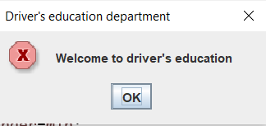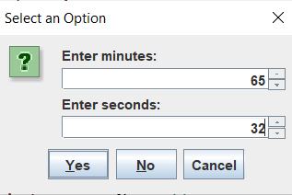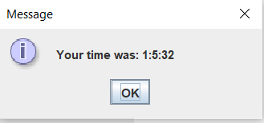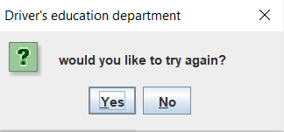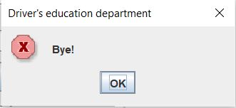

Question 8:

/**
* C-RAP
* Author: Adrian Pailler
* Date: 26/1/21
* Version: 1.0
* Description: does unit conversions for user
*/
package Methods;
import javax.swing.*;
public class Q8 {

public static void main(String[] args) {
final String title = "C-RAP converter"; // since title is reused, creating it as a string is more efficient
int flag = 0; // flag to break efficiently
while(flag==0) {
JOptionPane.showMessageDialog(null,"Welcome to C-RAP converter",title,0);
double[] choice = Choice(); // calls choice(25-42)
Converter(choice[0],choice[1]); // calls converter(43-89)
flag = JOptionPane.showConfirmDialog(null, "would you like to try again?",title,0); // loops back to 16 player chooses yes
}
if(flag==1) {
JOptionPane.showMessageDialog(null,"Thank you for using C-RAP conversion",title,0);
}
}
/**
* gets the users input for what type of conversion they want to use and also the values they need converted
* no parameters
* returns the choice of conversion (choice[0]) and the value to be converted (choice[1])
*/
public static double[] Choice() {
SpinnerModel limit = new SpinnerNumberModel(1,0,10000000,0.5);// initial, min, max, step
JSpinner input = new JSpinner(limit); // creates spinner
double[] choice= new double[2];
String [] buttons = { // creates the user input buttons
"1- Inches to Centimeters","2- Feet to Centimeters","3- Yards to Meters","4- Miles to Kilometers","5- Centimeters to Inches",
"6- Centimeters to Feet","7- Meters to Yards","8- Kilometers to Miles"};
choice[0] = JOptionPane.showOptionDialog(null,"Click a button","What would you like to convert",JOptionPane.DEFAULT_OPTION,JOptionPane.INFORMATION_MESSAGE,null,buttons,buttons[0]);
JOptionPane.showConfirmDialog(null,input);
choice[1] = (double) input.getValue(); // cannot return 1 value hence the array
return choice;

}
/**
* Converts the input to whichever unit the user chose out of the 8 options
* double double, the first being the type of conversion and the second is the amount of the value being converted all retrieved from choice()
* no returns
*/
public static void Converter(double choice, double amount) {
String initial; // both initial and last are used to display the name of the unit based on the type of conversion
String last;
double ans;
if(choice==0) { // finds the choice option the user picked
initial = "Inches";
last = "Centimeters";
ans=amount*2.54;
}else if(choice==1) {
initial = "Feet";
last = "Centimeters";
ans=amount*30.48;
}else if(choice==2) {
initial = "Yards";
last = "Meters";
ans=amount/1.0936133;
}else if(choice==3) {
initial = "Miles";
last = "Kilometers";
ans=amount*1.609344;
}else if(choice==4) {
initial = "Centimeters";
last = "Inches";
ans=amount/2.54;
}else if(choice==5) {
initial = "Centimeters";
last = "Feet";
ans=amount/30.48;
}else if(choice==6) {
initial = "Meters";
last = "Yards";
ans=amount*1.0936133;
}else {
initial = "Kilometers";
last = "Miles";
ans=amount/1.609344;
}
JOptionPane.showMessageDialog(null,amount+" "+initial+" Is equal to: "+ans+" "+last); /* amount: value of unit to be converted
initial: name of unit to be converted
ans: value of unit after conversion
last: name of unit after conversion */
}
}
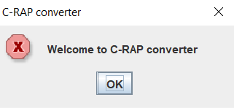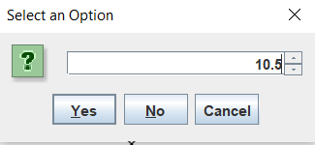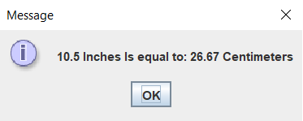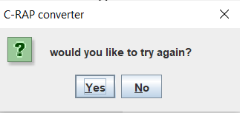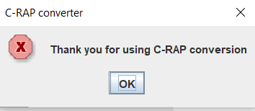

Question 14:

/**
* Mr. Teasdale's Rövarspråket (Robbers language)
* Author: Adrian Pailler
* Date: 28/1/21
* Version: 1.0
* Description: Converts normal English into robbers language
* Rules: 1. if letter is consonant leave it
* 2. get the closest vowel from consonant and put it in front of it
* 3. get next consonant of the original consonant
* 4. if the letter is a vowel, leave it
*/
package Methods;
import javax.swing.*;
public class Q14 {

public static void main(String[] args) {
final String title = "Rövarspråket"; // since title is reused, creating it as a string is more efficient
int flag = 0; // flag to break efficiently
while(flag==0) {
JOptionPane.showMessageDialog(null,"Welcome to Rövarspråket",title,0);
String input = input();
toRövarspråket(input);
flag = JOptionPane.showConfirmDialog(null, "would you like to try again?",title,0); // loops back to 16 player chooses yes
}
if(flag==1) {
JOptionPane.showMessageDialog(null,"Thank you for using Rövarspråket",title,0);
}
}
/**
* gets the users input
* no parameters
* returns the word to be translated (String)
*/
public static String input() {
String english = JOptionPane.showInputDialog(null,"Enter a word to translate: ");
if(english.matches("[a-zA-Z]+")) { // makes sure input is a word
return english.toLowerCase();
}else {
JOptionPane.showMessageDialog(null, "That is not a word...");
return null;
}
}
/**
* translates the English word to Rövarspråket
* String (English) takes the English input of the user to translate
* no return
*/
public static void toRövarspråket(String english) {
String consonants = "bcdfghjklmnpqrstvwxyz";
String collector = ""; // collects the individual chars of the translated word
char a='a'; // gets the nearest vowel
int index = 0; // gets index of next consonant
for(int i=0;i<english.length();i++) {
if(english.substring(i,i+1).matches("[^aeiou]")) { // checks if the letter at index i is a consonant
if(english.charAt(i)<='c') { // if it isn't a consonant || 55-65 gets the nearest vowel
a='a';
} else if(english.charAt(i)<='g') {// finds the closest vowel
a='e';
} else if(english.charAt(i)<='l') {//
a='i';
} else if(english.charAt(i)<='r') {//
a='o';
} else if(english.charAt(i)<='z') {//
a='u';
} // 66-70 gets next consonant
if(english.charAt(i)=='z') { // if consonant is 'z', get 'b' the first consonant in the alphabet
index=consonants.indexOf('a');
} else { // if it is not 'z'
index = consonants.indexOf(english.charAt(i));
}
collector = collector+english.charAt(i);// adds the orginal consonant of the string
collector = collector+a;// adds the nearest vowel after
collector = collector+consonants.charAt(index+1);// adds the next consonant last
} else {// if it is a consonant, leaves it
collector = collector+english.charAt(i);
}
}
JOptionPane.showMessageDialog(null, "The word "+english+" in Rövarspråket is "+collector);
}
}
